Web Server Report  
Team RAJ – Angelica Rodriguez, John Krasich CSSE 477

Table of Contents

**Milestone 1** 3

**Architecture Diagram** 3

**Detailed Design** 4

**Further Improvements** 5

**Test Report** 6

**Testing Utility** 6

**Web Browser** 10

**Change History – MS2** 11

**Updated Architecture Diagram** 11

**Updated Detailed Design** 12

**Brief Description** 12

**Feature Listing & Assignment** 13

**Test Report** 14

**Plugin Addition** 14

**POST** 15

**GET** 16

**PUT** 17

**DELETE** 18

**Future Improvements** 19

**Change History – MS3** 20

**Updated Architecture Diagram** 21

**Updated Detailed Design** 22

**Brief Description** 22

**Tactics/Feature Listing** 23

**Architectural Evaluation and Improvements** 24

**Availability** 24

**Performance** 24

**Security** 24

**Future Improvements** 26

# **Milestone 1**

## **Architecture Diagram**

**Protocol**

**Server**

**Client**

## 

Protocol

Server

## 

Web browser

Connection Handler

HTTP Response

Web Server GUI

HTTP Request

400

200

404

304

## 

Request

Response

PUT

POST

505

GET

DELETE

## **Detailed Design**

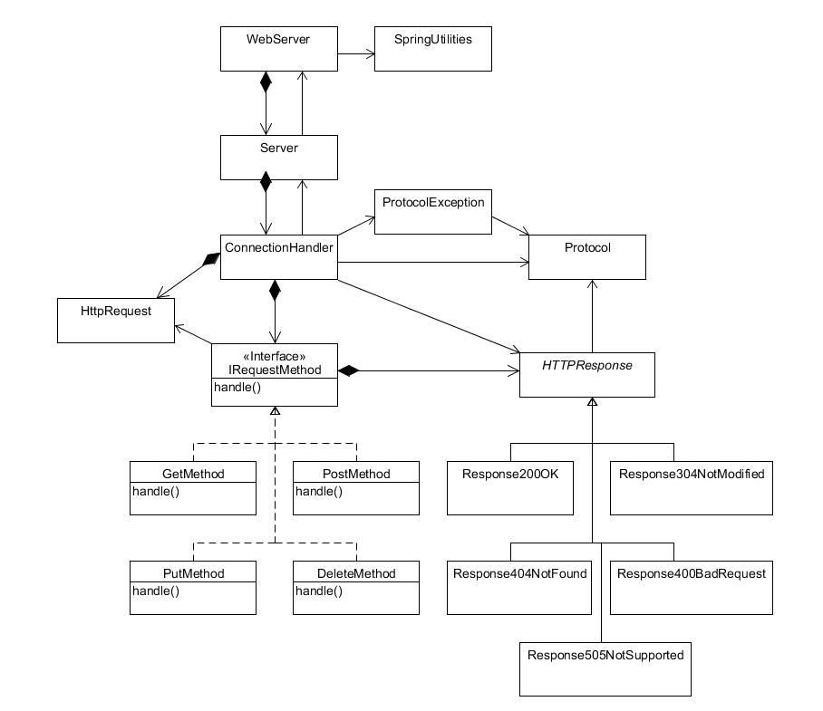

Our refactoring of the web server utilized the following design patterns:

**Strategy Pattern** – The IRequestMethod interface allows for the various implementations of request handling to be completed in unique classes. This way, additional request handling can implanted with minimal changes to the ConnectionHandler class – simply add the new request to the ConnectionHandler’s map of request methods.

**Bridge Pattern** – The abstract HTTPResponse class is used by the ConnectionHandler to write the generated response back to the client. However, the responses vary depending on the response code. Using a bridge pattern, each different response’s implementation can be handled in separate classes without the ConnectionHandler needing to have any knowledge of how it is implemented.

## **Further Improvements**

One area that can be further refactored would involve dividing the responsibilities of the ConnectionHandler class separately between requests and responses. The “run” method is rather long – breaking this up into different methods (or different classes) would make the code much more organized and easier to understand.

## **Test Report**

### **Testing Utility**

#### **DELETE of Non-Existent File**

Before:

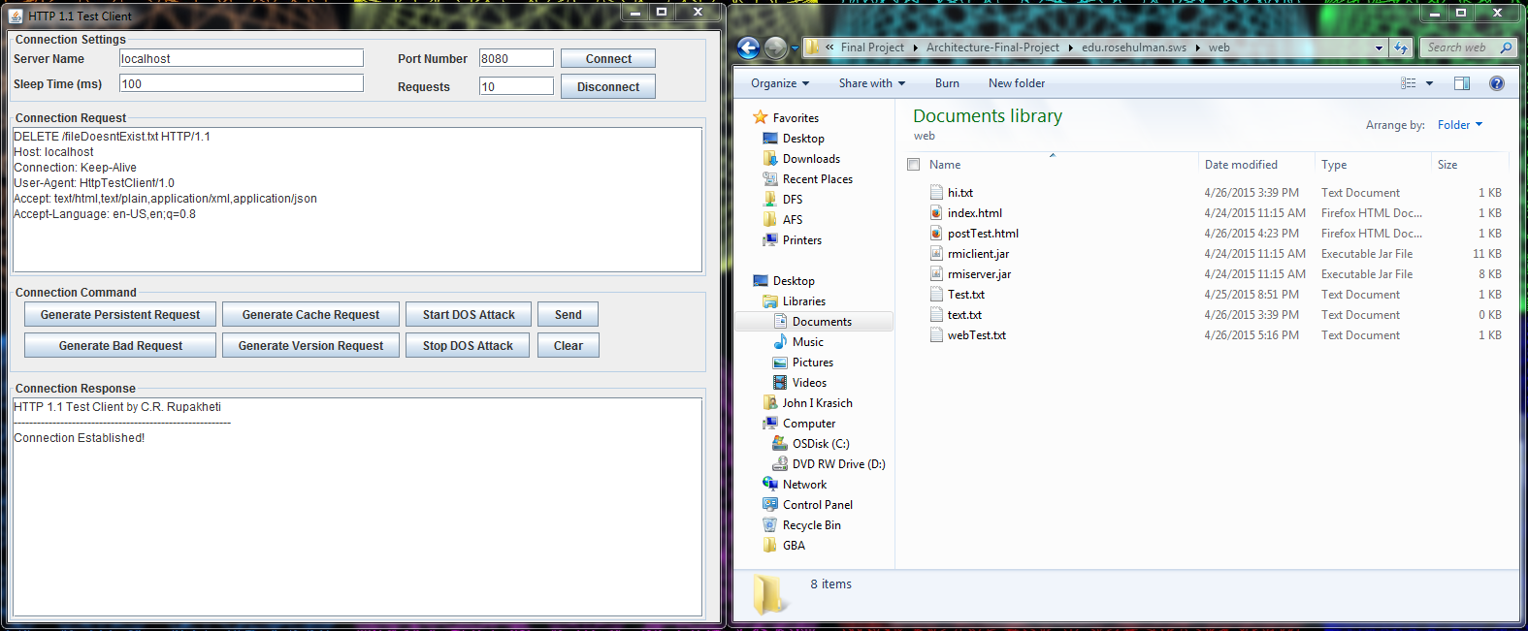

After: Response 404 Not Found

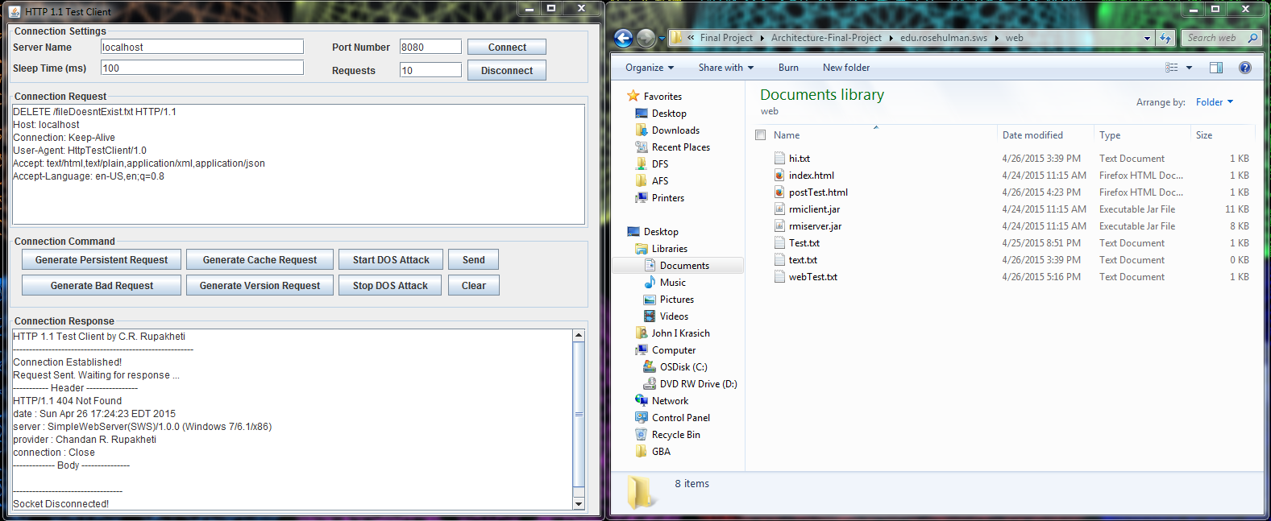

#### **DELETE**

Before:

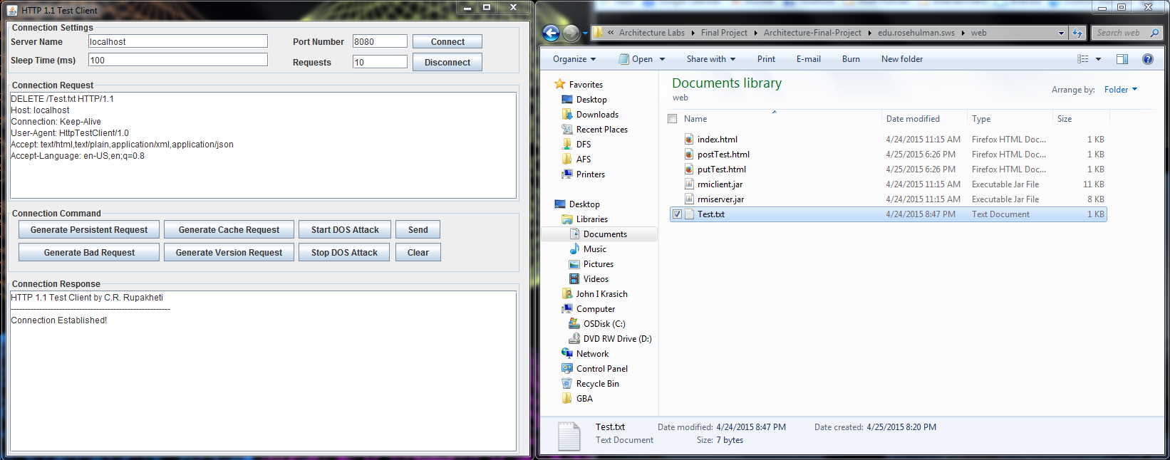

After: Response – 200 OK. File Test.txt has been deleted successfully

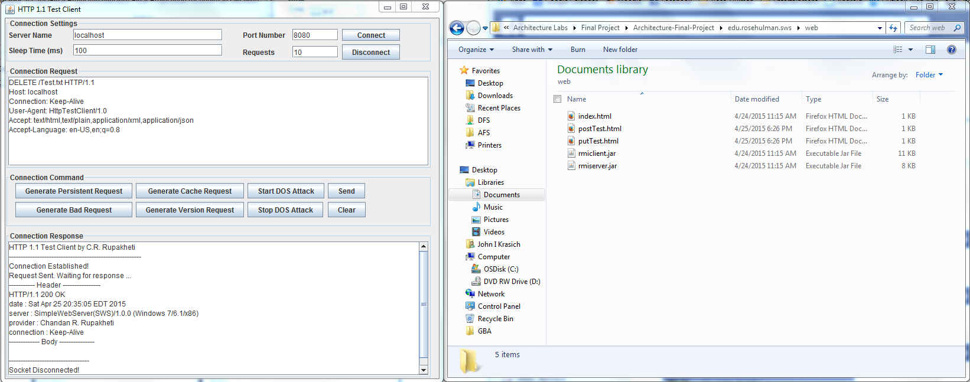

#### **POST**

Before:

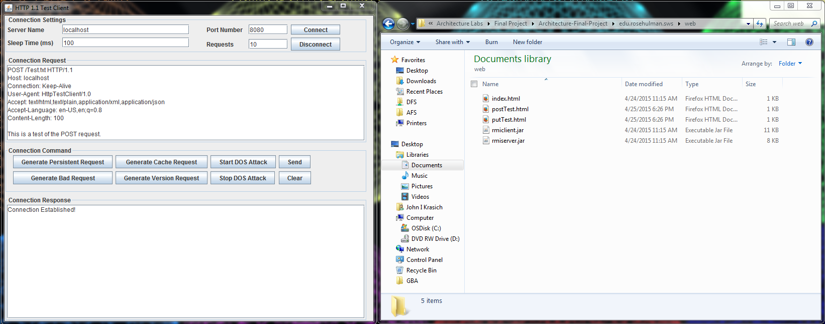

After: Response 200 OK. The file Test.txt has been created and filled with the body of the request.

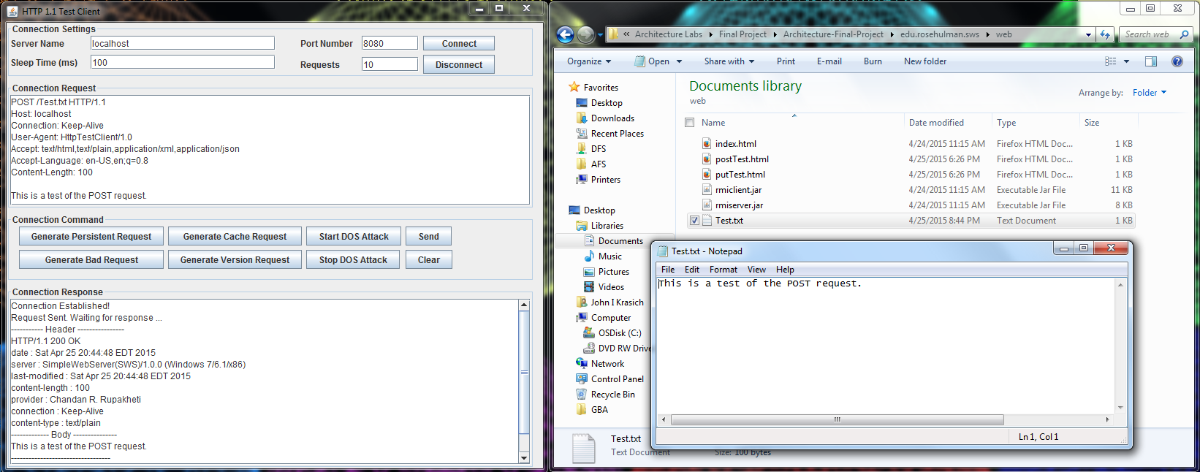

#### **PUT**

Before:

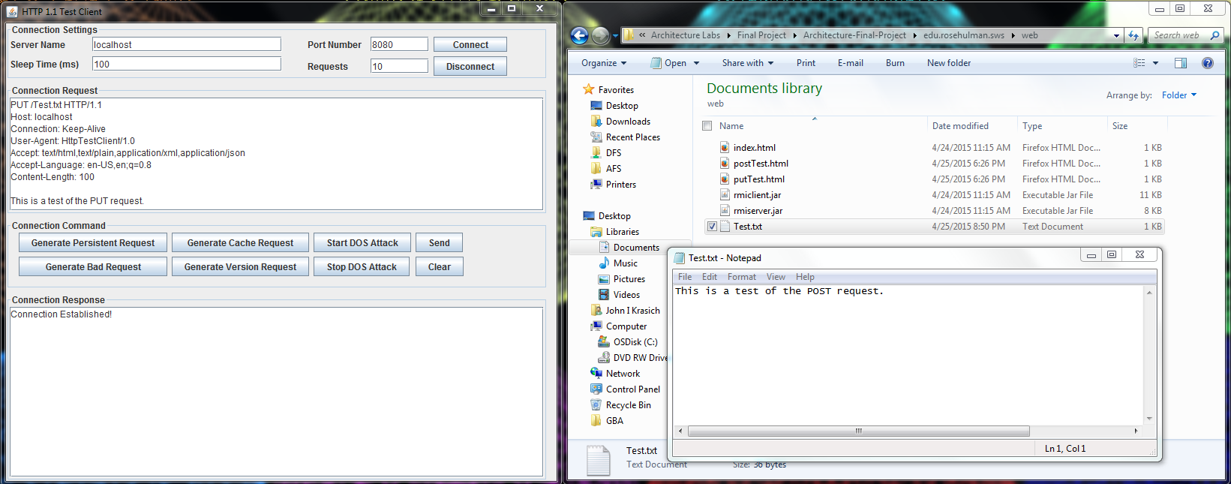

After: Response 200 OK. The body of the request was appended to the Test.txt file.

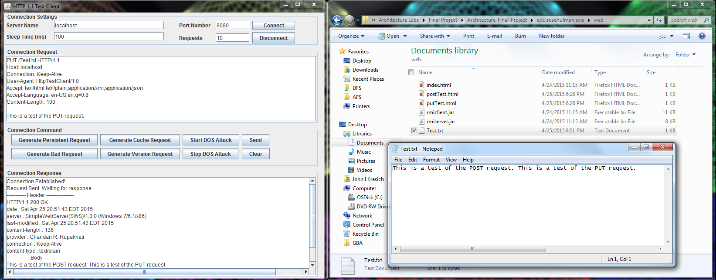

### **Web Browser**

#### **POST**

Before:

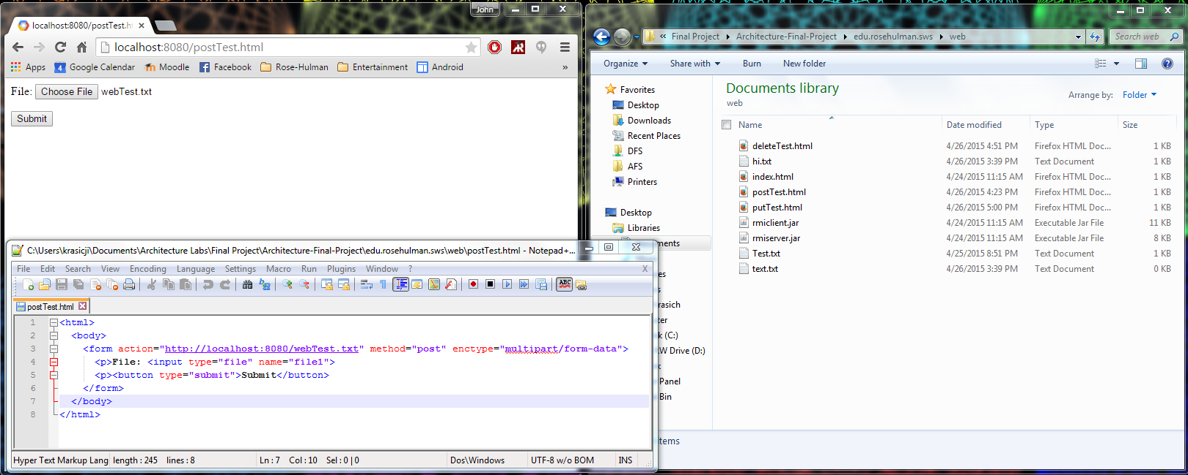

After: Response 200 OK – the text of the file was written into webTest.txt and returned as the body in the response.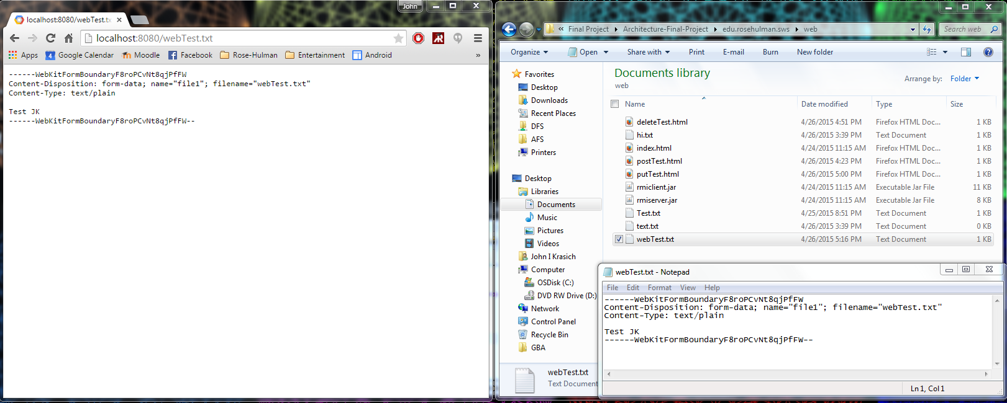

# **Change History – MS2**

## **Updated Architecture Diagram**

**Server**

## 

**Protocol**

**Client**

Connection Handler

Server

## 

Protocol

Web browser

HTTP Response

Plugin Handler

304

200

400

Servlet

Web Server GUI

404

StaticPUT

StaticPOST

Request

Response

## 

505

## 

StaticDELETE

StaticGET

## 

UserServlet

## **Updated Detailed Design**

### **Brief Description**

The most significant changes made for this milestone were the addition of the PluginHandler class and Servlet Interface. The PluginHandler watches a Plugins directory for the addition of Jar files from which new servlets would be dynamically included into the web server. The ConnectionHandler communicates with the PluginHandler, passing along the request for the PlugHandler to process correctly. This is done through a HashMap, which relates the context root to a second HashMap that stores the servlets and their respective URIs. Any servlet must implement the Servlet interface, which contains information necessary for the PluginHandler as well as its custom request processing method. The basic GET, POST, PUT, and DELETE methods from MS1 became “static servlets” that will be run if no plugin is found for that kind of request.

## **Feature Listing & Assignment**

**Angelica Rodriguez**

* W-1: GET Requests
* W-2: POST Requests
* W-3: PUT Requests
* W-4: DELETE Requests

**John Krasich**

* P-1: Dynamic Loading
* E-1: Root Context and Configurable Route
* Test Report

## **Test Report**

### **Plugin Addition**

Before:

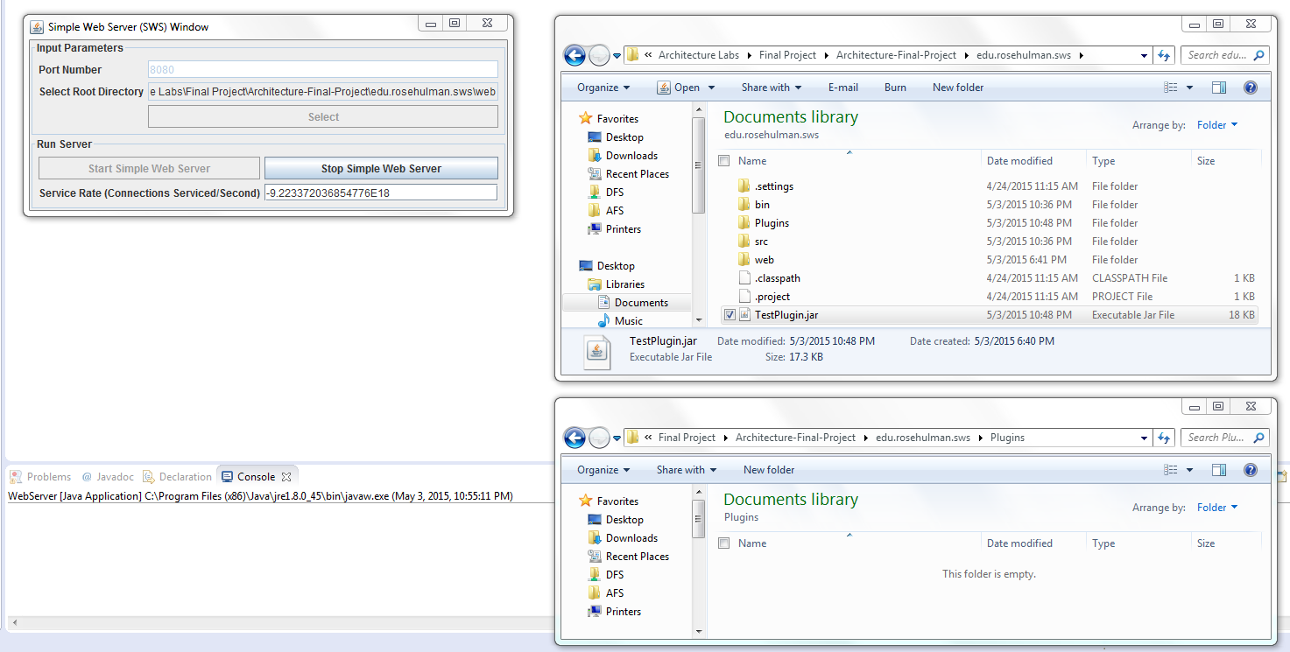

After: the plugin containing two servlets were dynamically loaded into the web server.

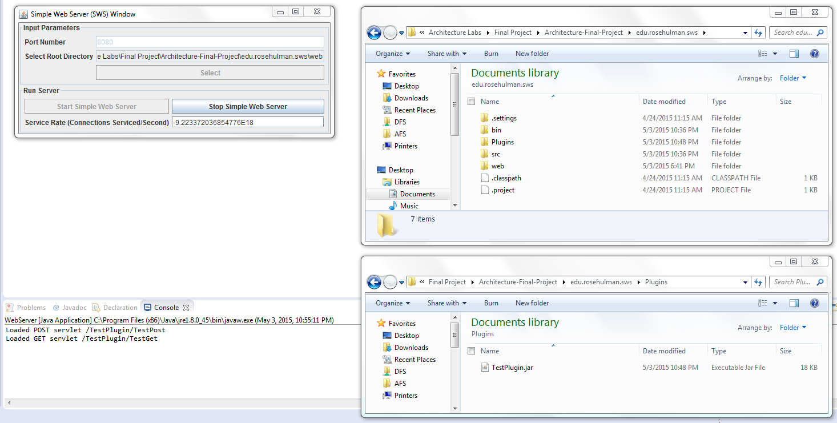

### **POST**

Before:

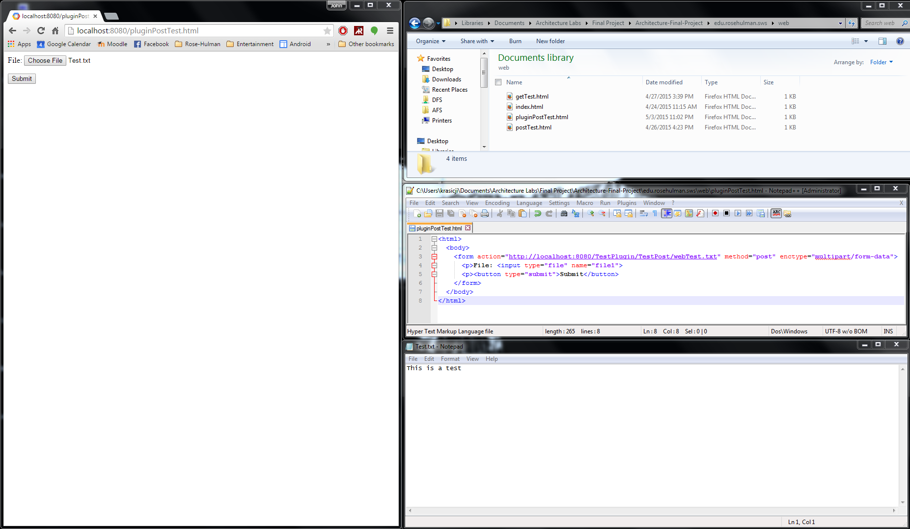

After: the servlet appended “THIS IS PROFF THAT THE SERVLET WORKS. WOOOOOT” to the file + body.

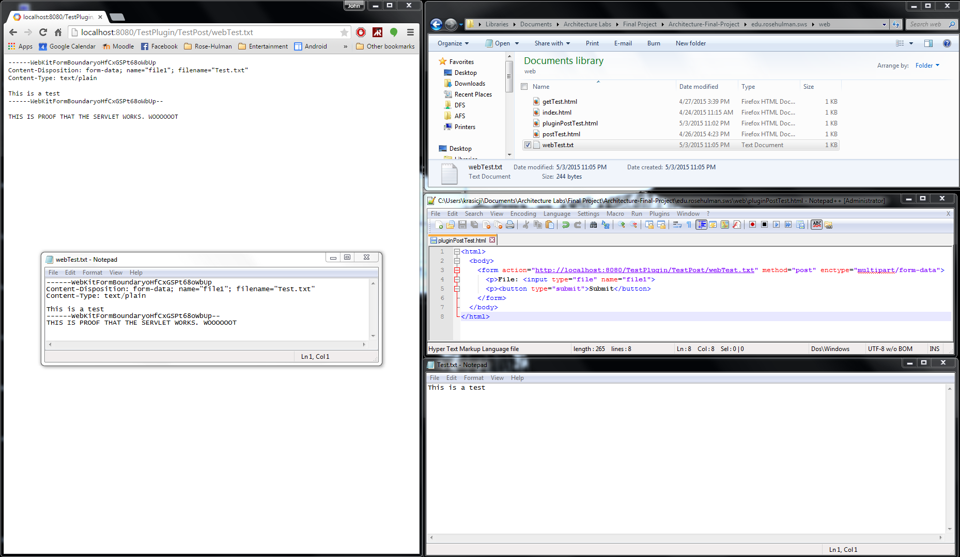

### **GET**

Before:

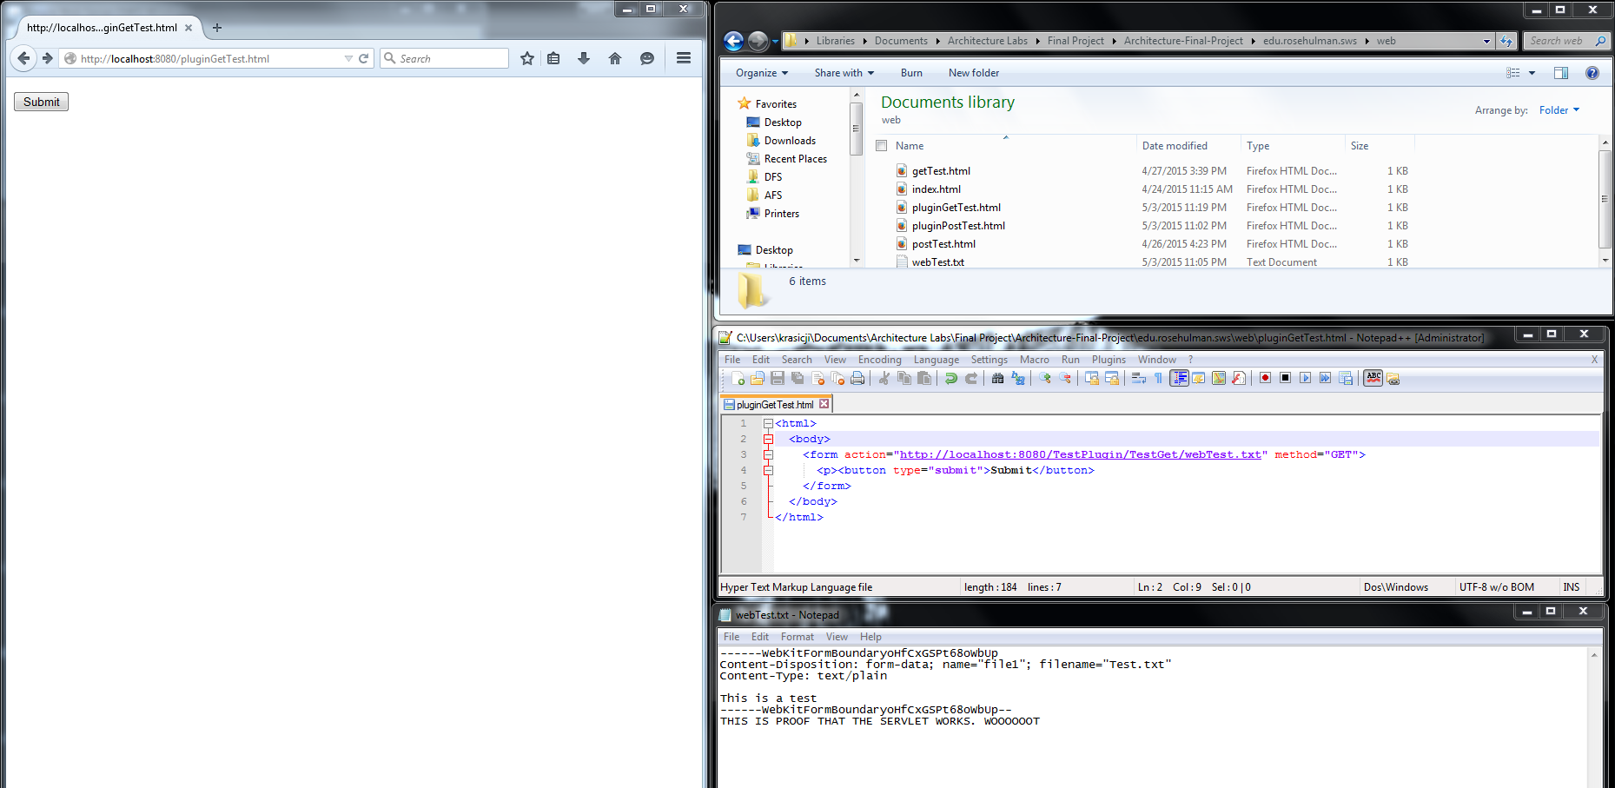

After: the servlet appended an additional header to the response.

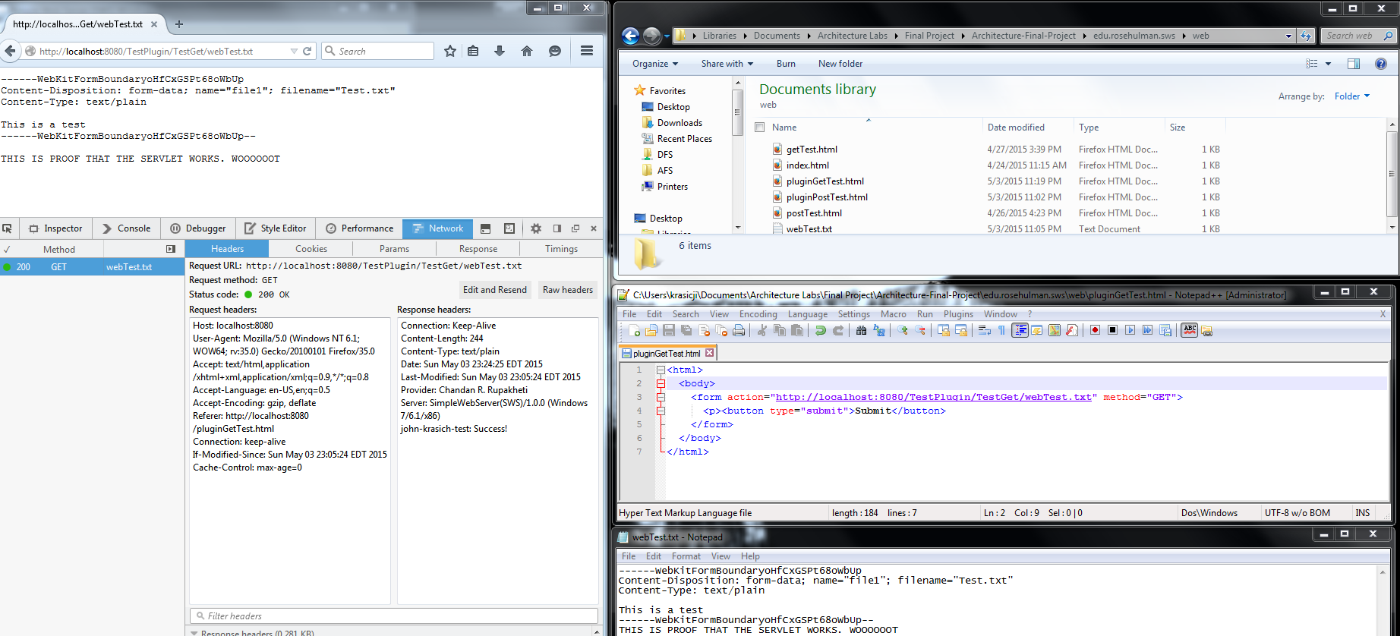

### **PUT**

Before:

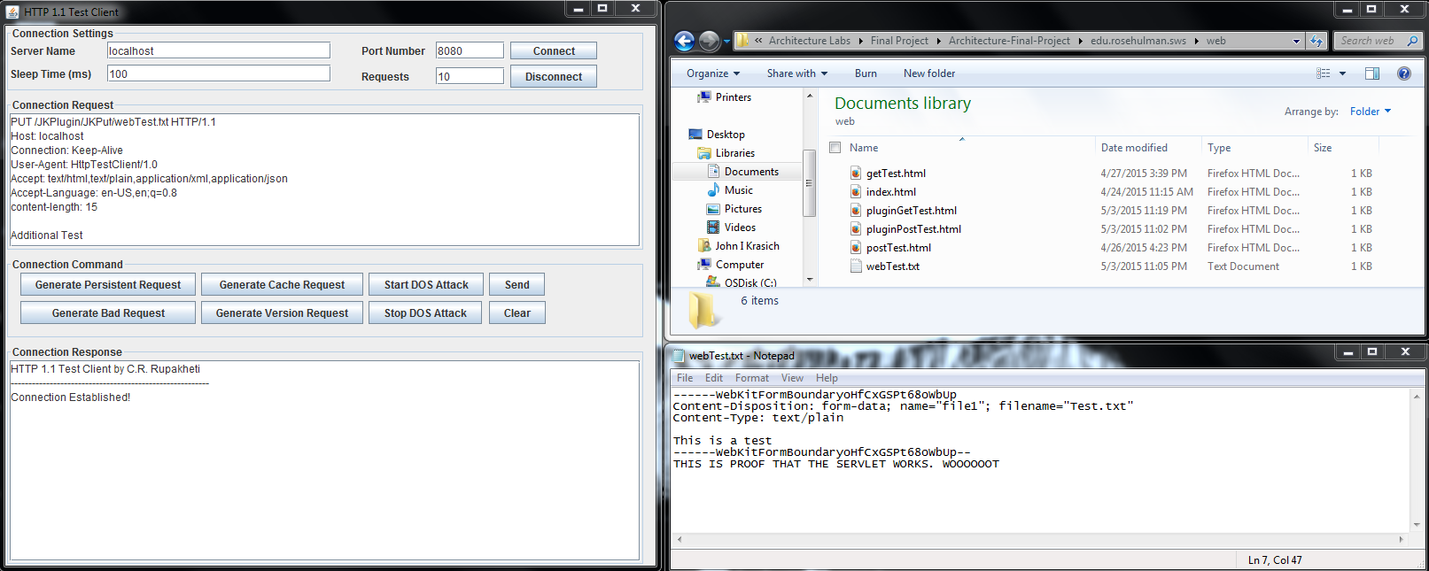

After: the servlet appended the extra text “The plugin has inserted this line into the text” into the file.

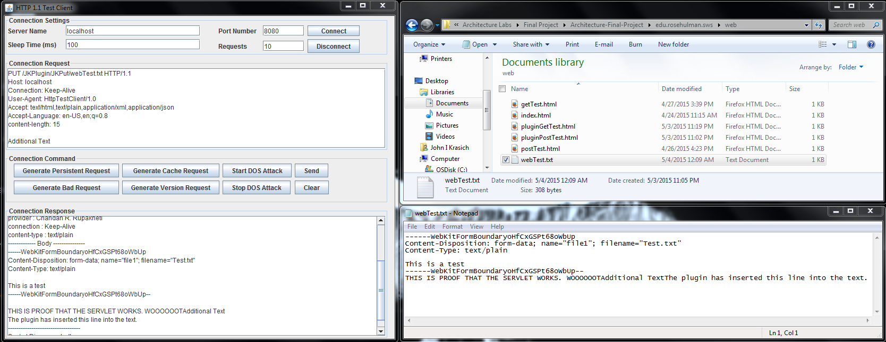

### **DELETE**

Before:

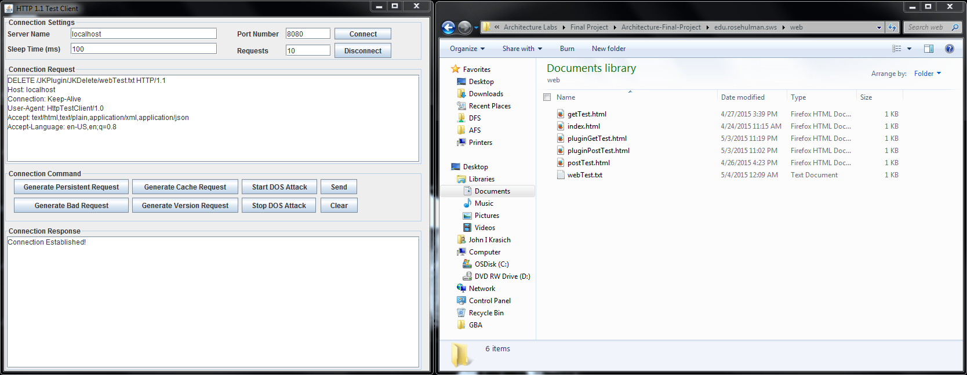

After: the servlet appended an extra header into the delete response.

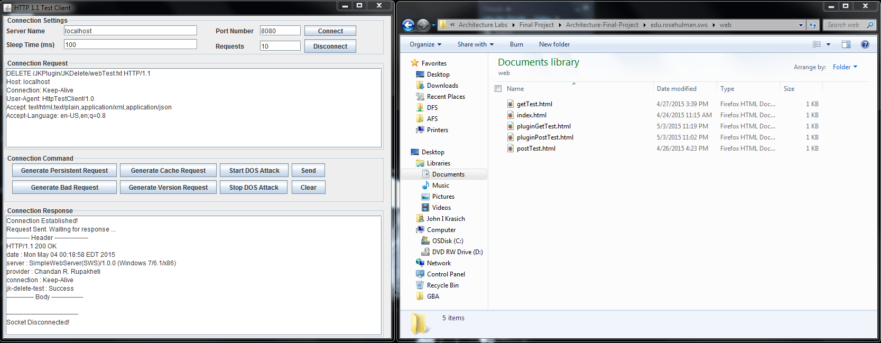

## **Future Improvements**

One idea we did not get to try but wanted to was to have the users supply a configuration file for the servlets with the information necessary, rather than have them hardcode the request code and create the JAR file. This would be a significant improvement because it would allow it to be easily modifiable, since they could make changes dynamically.

# **Change History – MS3**

## **Updated Architecture Diagram**

## **Updated Detailed Design**

### **Brief Description**

## **Tactics/Feature Listing**

## **Architectural Evaluation and Improvements**

### **Availability**

#### **A1**

* A1.1 Concrete Secenario
* A1.2 Test Plan
* A1.3 Baseline
* A1.4 Improvement Tactics
* A1.5 Conclusion

#### **A2**

* A2.1 Concrete Secenario
* A2.2 Test Plan
* A2.3 Baseline
* A2.4 Improvement Tactics
* A2.5 Conclusion

### **Performance**

#### **P1**

* P1.1 Concrete Secenario
* P1.2 Test Plan
* P1.3 Baseline
* P1.4 Improvement Tactics
* P1.5 Conclusion

#### **P2**

* P2.1 Concrete Secenario
* P2.2 Test Plan
* P2.3 Baseline
* P2.4 Improvement Tactics
* P2.5 Conclusion

### **Security**

#### **S1**

* S1.1 Concrete Secenario
* S1.2 Test Plan
* S1.3 Baseline
* S1.4 Improvement Tactics
* S1.5 Conclusion

#### **S2**

* S2.1 Concrete Secenario
* S2.2 Test Plan
* S2.3 Baseline
* S2.4 Improvement Tactics
* S2.5 Conclusion

## **Future Improvements**